Proactive Resilience of Urban Water Supply Cyber-Physical Systems under Extreme Water Network Malfunctions: An Early-Warning Management Perspective
Abstract
Urban water supply cyber-physical systems (CPS) hold significant potential for enhancing proactive resilience by exploiting the time gap between fast cyber sensing and gradual hydraulic degradation. However, existing research largely focuses on resilience assessment, with limited proactive resilience optimization that translates early warning signals into systematic operational responses under extreme water network malfunctions. To address this gap, we develop a co-simulation framework that integrates the Water Network Tool for Resilience (WNTR), the EPANET 2.2 hydraulic solver, and supervisory control and data acquisition (SCADA) control logic. Simulations are performed on the Anytown benchmark network over a 72-h horizon, covering complete source interruption scenarios lasting 24–48 h. Early warning management (EWM) is implemented via three staged demand-retention levels: 70%, 40%, and 20% of baseline demand. System performance is evaluated using a pressure-based resilience index $\left({\text{RI}}_{\text{pressure}}\right)$, a service-based resilience index $\left({\text{RI}}_{\text{service}}\right)$, and the demand satisfaction ratio $\left(\text{DSR}\right)$. Results demonstrate that EWM transforms system failure patterns from abrupt collapse to controlled degradation. Under a 24-h outage, EWM increases total delivered water volume by 36.2% (from 1353.5 m³ to 1843.1 m³), reduces cumulative unmet demand by 8.8% (from 6469.3 m³ to 5979.7 m³), and maintains pipeline head above the 0.10 MPa emergency threshold. A multi-factor sensitivity analysis across risk-threshold perturbations (ΔH = −1.0 to +1.0 m), tank storage capacities (0.6–1.4 times baseline), and outage durations (12–48 h) reveals that EWM effectiveness is strongly stress-dependent. The analysis further identifies operational boundaries and over-curtailment risks under low-stress conditions. These findings provide quantitative decision support for stress-aware emergency load shedding and adaptive dispatch planning in municipal water utilities.
Keywords: Cyber-physical systems; Urban water supply; Proactive resilience; Early-warning management; Graded demand management; Pressure-driven analysis
1. Introduction
Urban water supply systems constitute critical lifeline infrastructure underpinning urban public health, fire safety, and sustained economic operation. Driven by rapid urbanization and digital transformation, conventional water distribution networks are evolving into complex cyber-physical systems (CPS) (Alexandra et al., 2023; Ande et al., 2020; Liao et al., 2025). Physical assets including reservoirs, pumping stations, distribution mains, and storage tanks are increasingly integrated with cyber layers such as supervisory control and data acquisition (SCADA) systems, programmable logic controllers (PLCs), wireless sensor networks, and automated control valves (Bhardwaj et al., 2021; Khan et al., 2020; Yadav & Paul, 2021). While this integration elevates routine operational efficiency, it also exposes water supply CPS to a wider spectrum of severe disruptions, ranging from extreme natural hazards and climate-driven events to power blackouts and source contamination (Argyroudis et al., 2022; Boltz et al., 2019; Khattak, 2024; Mohebbi et al., 2020).
Catastrophic events causing complete source interruption can trigger immediate collapse of primary pumping capacity. Existing risk management practices remain largely rooted in a passive fail-and-repair paradigm (Holling, 1973; Hosseini et al., 2016), where recovery relies on physical remediation of pumping facilities or source water quality—a process that typically takes hours to days. During this recovery window, unregulated demand rapidly depletes emergency tank storage, initiating a cascade of hydraulic degradation including pressure decay, air binding, and eventual large-scale service interruption (He et al., 2024; Wu & Li, 2021). This inherent vulnerability underscores an urgent need to shift from passive disturbance tolerance to proactive resilience, whereby cyber monitoring and operational control are deployed to mitigate system degradation before irreversible collapse occurs (Garcia-Perez et al., 2023; He et al., 2023).
A largely underexploited advantage of water supply CPS lies in the inherent time-scale mismatch between cyber sensing and hydraulic deterioration. SCADA telemetry delivers status updates within seconds, whereas tank drawdown and head loss propagate gradually over hours. In a coupled CPS architecture, this temporal gap means risk detection and warning signals can be generated well before irreversible hydraulic failure takes place (Arghandeh et al., 2016; Hassanzadeh et al., 2020), creating a quantifiable intervention window (ΔT). When early warning signals are translated into timely control actions, this passive physical time margin can be converted into active resilience capacity, forming the core mechanism of proactive resilience enhancement.
Despite expanding research on smart water systems, three critical methodological and managerial gaps persist. First, CPS-focused studies in the water domain predominantly address cybersecurity, attack detection, and leak localization (Bhardwaj et al., 2021; Hassanzadeh et al., 2020; Taormina et al., 2018; Yadav & Paul, 2021), with limited examination of how high-speed cyber sensing can enable operational control under extreme physical disruptions such as total source outage. Second, mainstream resilience assessment frameworks rely heavily on topology-based metrics or pressure preservation criteria (Cai et al., 2021; Casal-Campos et al., 2018; Chen et al., 2025a, 2025b; Hosseini et al., 2016; Hou et al., 2023; Liu et al., 2020; Meng et al., 2018; Zhang et al., 2022). Under emergency demand curtailment, pressure-only indices may overestimate system resilience by failing to account for degraded service levels and unmet user demand. Third, early warning research in water engineering is frequently confined to alarm generation or auxiliary routing support (Juan-Garcia et al., 2017; Liu, 2019; Liu & Mijic, 2025; Liu et al., 2023a; Wardropper & Brookfield, 2022), with few studies establishing a closed-loop integration with graded demand management strategies. Consequently, the quantitative mechanism linking warning signals to tangible water delivery gains, as well as its stress-dependent operational boundaries, remains insufficiently characterized.
To address these gaps, this study develops an integrated CPS co-simulation and resilience evaluation framework for the Anytown benchmark network under complete source interruption scenarios. The framework is built on the Water Network Tool for Resilience (WNTR), incorporating the EPANET 2.2 pressure-driven hydraulic solver, and coupled with SCADA-based tank level monitoring and automated emergency control logic. Early warning management (EWM) is operationalized via three staged demand-retention tiers set at 70%, 40%, and 20% of baseline demand. This work makes three distinct contributions: (1) It proposes a closed-loop emergency response strategy that mitigates abrupt zero-supply collapse induced by uncontrolled tank depletion during source interruption events; (2) It establishes a cyber-physical co-simulation framework that connects real-time early warning signals to executable graded demand management protocols; (3) It quantifies the ΔT-based buffering mechanism and evaluates its stress-dependent effectiveness in extending supply duration, maintaining emergency hydraulic head, and improving overall water delivery performance.
2. Methodology
2.1 Benchmark Network and CPS Co-Simulation Platform
The proposed CPS framework is validated using the well-established Anytown water distribution benchmark network (Walski et al., 1987). As illustrated in Fig. 1, the physical system comprises 19 demand nodes, 34 pipelines, two elevated storage tanks (T1, T2), one source reservoir (R), and a main pumping station equipped with two identical parallel pumps (P1, P2). Raw water is withdrawn from reservoir R and pressurized for distribution across the network. Tanks T1 and T2 are deployed on opposite sides of the network to facilitate peak load shaving and stabilize nodal hydraulic pressure.
The two tanks share uniform geometric parameters: base elevation of 66.54 m, internal diameter of 9.95 m, maximum water depth of 10.67 m, and an initial pre-disturbance water level of 3.051 m. SCADA sensors continuously track real-time tank water levels, nodal hydraulic heads and pump operational statuses.
The co-simulation environment is built upon the Water Network Tool for Resilience (WNTR), coupled with the EPANET 2.2 pressure-driven hydraulic solver. Simulations run over a 72-hour time horizon with a fixed 300-second (5-min) time step. At each time step, a five-stage closed control loop is executed (Fig. 2):
(1) EPANET 2.2 computes nodal heads, pipe flow rates and transient tank water levels;
(2) SCADA collects tank water level ${\text{H}}_{\text{tank}}\left(\text{t}\right)$ and pump status ${\text{S}}_{\text{pump}}\left(\text{t}\right)$, and archives measurements in a SQLite database;
(3) The cyber monitoring module compares ${\text{H}}_{\text{tank}}\left(\text{t}\right)$ against predefined risk thresholds (5.0, 4.0, 2.0, 0.50 m) during source interruption events;
(4) Once a threshold is breached, the controller activates a monotonic ratchet constraint ${\text{γ}}_{\text{t}} \text{≤} {\text{γ}}_{\text{t}\text{−}\text{1}}$ to eliminate control chattering and updates the demand-retention multiplier $\text{γ} \text{∈} \left\{\text{1.00, 0.70, 0.40, 0.20}\right\}$;
(5) AMI-enabled smart meters and pressure-reducing valves enforce adjusted nodal demand for the subsequent simulation timestep.
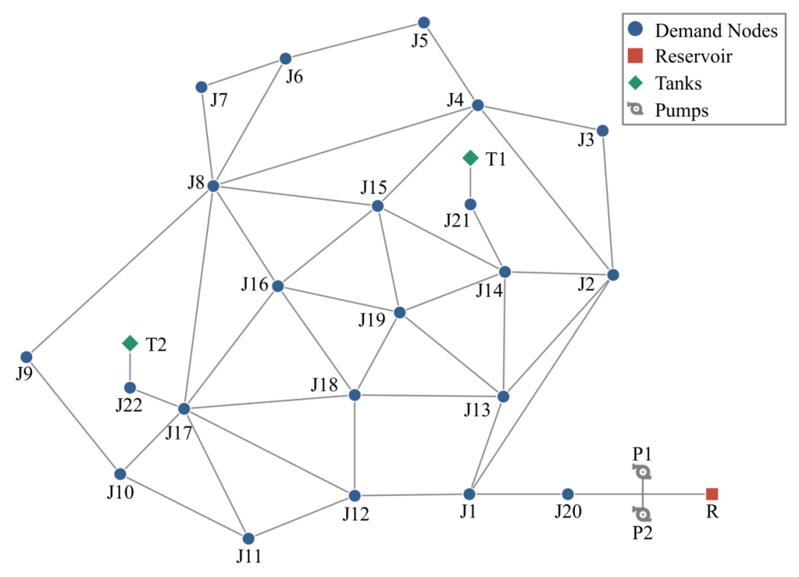
Fig. 1. Topology of the Anytown water distribution network, including junction nodes, pipelines, reservoir R, parallel pumps P1/P2, and storage tanks T1/T2.
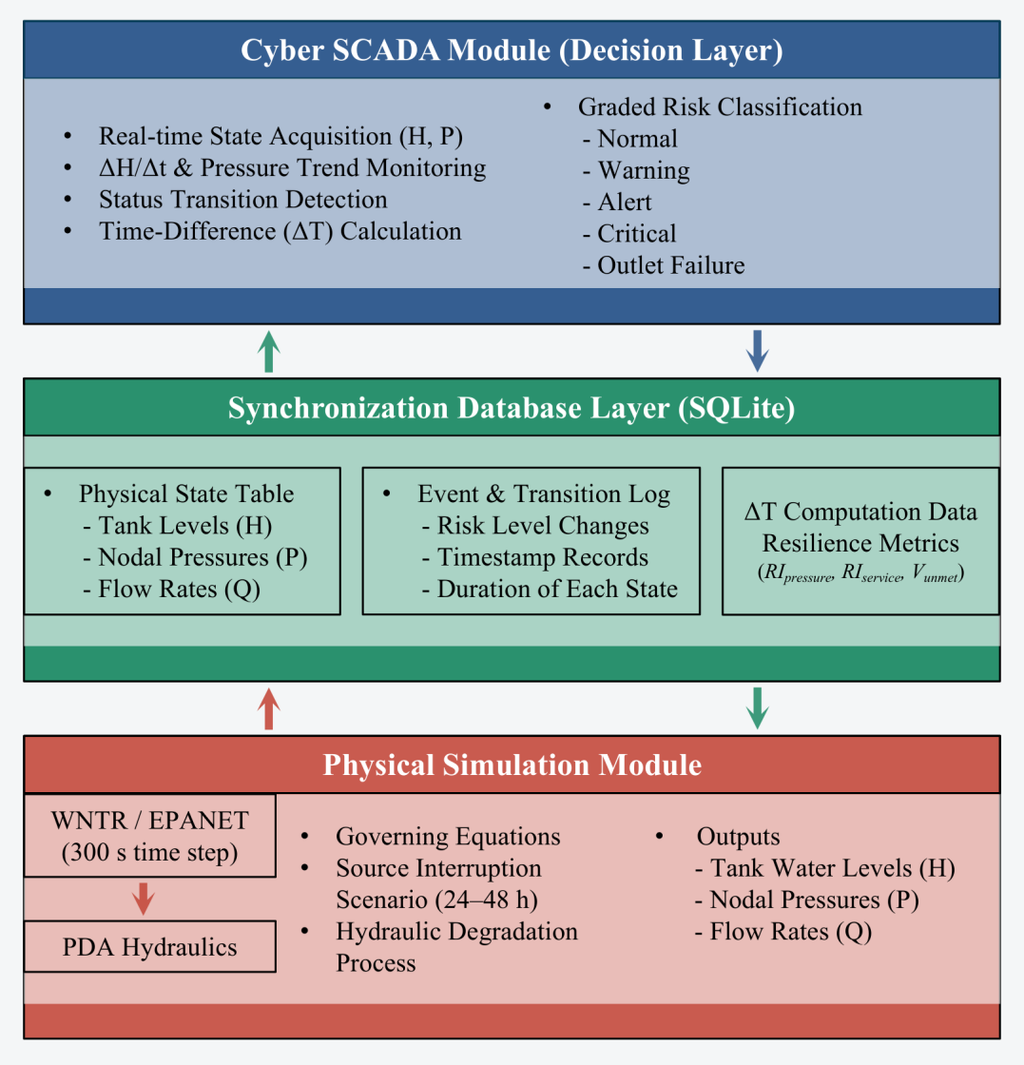
Fig. 2. Integrated WNTR/EPANET 2.2 co-simulation workflow and embedded SCADA closed control loop.
2.2 Idealized Assumptions and Scope Boundaries
To construct a controlled baseline for quantifying proactive cyber-physical resilience, the co-simulation model adopts a set of idealized assumptions regarding cyber communication, control actuation and hydraulic dynamics. Table 1 systematically clarifies these assumptions, evaluates their potential deviations from engineering practice, and identifies feasible mitigation strategies for real-world deployment.
Table 1: Modeling assumptions, practical impacts, and mitigation options
Domain | Idealized Assumption | Practical Impact | Engineering Mitigation
Cyber Sensing | Sensors provide continuous, error-free SCADA telemetry of tank levels and pump states. | Measurement noise or sensor drift could cause premature or delayed EWM triggering. | Implement local Kalman filtering and dual-redundant sensor polling at tank sites.
Communication Network | Zero transmission latency, zero packet loss, and infinite bandwidth between SCADA and PLCs. | Network congestion or signal packet loss may delay demand reduction commands by seconds to minutes. | Deploy edge-computing PLCs capable of autonomous threshold evaluation during network outages.
Control Execution | Nodal demand curtailment is executed instantaneously and uniformly across all customer nodes. | Physical valve throttling at customer service connections requires finite mechanical actuation time. | Implement automated AMI-enabled smart meters and pressure-reducing valves (PRVs) with pre-set emergency routines.
Hydraulic Quality | Water quality (e.g., chlorine residual, age) is assumed non-degrading during emergency supply. | Low-flow velocity during severe demand curtailment may increase water age and stagnation. | Limit CRITICAL state duration and enforce post-event pipe flushing protocols.
Disturbance Scenario | Water source outage is modeled as a deterministic, step-function total pump shutdown (24–48 h). | Real-world power outages or pipe bursts may exhibit partial or cascading failure dynamics. | Conduct multi-factor sensitivity analysis across varying outage durations (12–48 h).

2.3 Early warning management and Graded Demand Management
Beyond passive status logging and simple alarm generation, the proposed cyber-physical early warning management (EWM) framework translates real-time risk detection into closed-loop emergency hydraulic interventions. As demonstrated by the three-layer CPS architecture in Fig. 3, the system consists of three tightly coupled layers. In the Cyber Sensing Layer, sensors sample tank water level ${\text{H}}_{\text{tank}}\left(\text{t}\right)$ and pump status ${\text{S}}_{\text{pump}}\left(\text{t}\right)$ at 300-second intervals and transmit telemetry data to the cyber control layer via gateway interfaces. In the Cyber Control Layer, upon confirmation of source interruption (${\text{S}}_{\text{pump}}\left(\text{t}\right)=0$, activated at t = 24 h), the controller evaluates tank water levels against predefined risk thresholds (5.0 m, 4.0 m, 2.0 m, 0.50 m). The monotonic ratchet constraint ${\text{γ}}_{\text{t}} \text{≤} {\text{γ}}_{\text{t}\text{−}\text{1}}$ is enforced to avoid oscillatory control outputs, and state-dependent demand multipliers $\text{γ} \text{∈} \left\{\text{1.00, 0.70, 0.40, 0.20}\right\}$ are issued accordingly. In the Physical Hydraulic Layer, demand reduction commands are executed at distribution junctions to restrain consumer outflow, slow volumetric drawdown of tank storage, maintain submerged tank outlets above 0.50 m, and sustain pipeline pressure beyond the 0.10 MPa emergency threshold.
$$\begin{aligned}Demand\left(j, t\right)=γ\left(t\right)∙BaseDemand\left(j\right)∙pattern\left(t\right)\#(1)\end{aligned}$$
Where $\text{γ}\left(\text{t}\right)$ denotes the time-variant demand-retention multiplier.

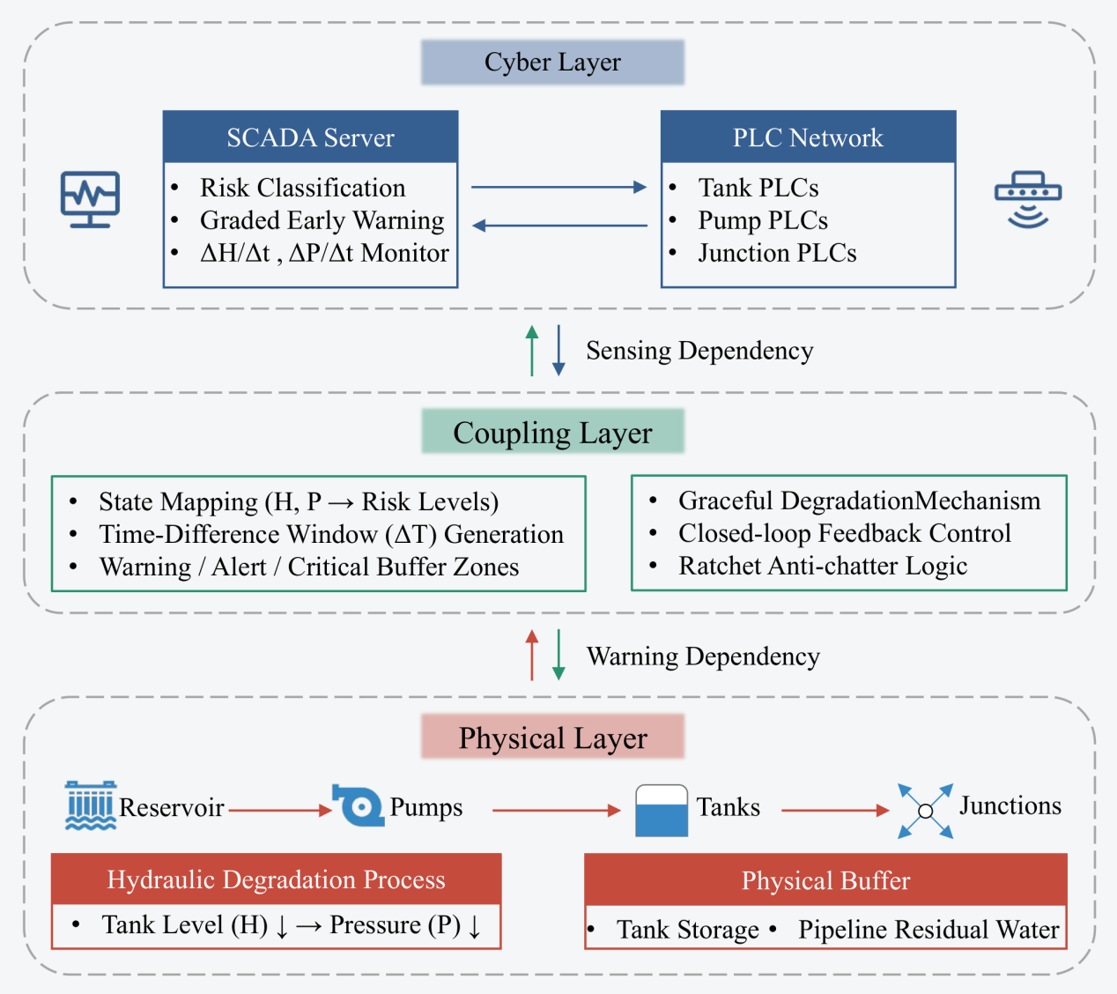
Fig. 3. Three-layer Cyber-Physical System (CPS) architecture illustrating closed-loop interaction among Sensing, Control, and Physical Hydraulic layers.
Trigger logic and corresponding control actions for each operational state are summarized in Table 2.
Table 2: Operational trigger logic and demand management actions of EWM
Risk State | Tank Level Threshold $\left({\text{H}}_{\text{tank}}\right)$ | Pump Status $\left({\text{S}}_{\text{pump}}\right)$ | Demand Multiplier $\left(\text{γ}\right)$ | Operational Action and Hydraulic Effect
NORMAL | $${\text{H}}_{\text{tank}} \text{≥}\text{ 5.0 m}$$ | Operational $\left(\text{S} \text{=}\text{ 1}\right)$ | 1.00 | Regular supply; 100% nominal demand delivered.
WARNING | $${\text{H}}_{\text{tank}} \text{<}\text{ 5.0 m}$$ | Outage $\left(\text{S} \text{=}\text{ 0}\right)$ | 0.70 | Level 1 curtailment; 30% non-essential demand shed; slows initial storage depletion.
ALERT | $${\text{H}}_{\text{tank}} \text{<}\text{ 4.0 m}$$ | Outage $\left(\text{S} \text{=}\text{ 0}\right)$ | 0.40 | Level 2 curtailment; 60% demand shed; preserves pressure above critical supply head (0.10 MPa).
CRITICAL | $${\text{H}}_{\text{tank}} \text{<}\text{ 2.0 m}$$ | Outage $\left(\text{S} \text{=}\text{ 0}\right)$ | 0.20 | Level 3 curtailment; 80% demand shed; maintains minimum emergency head and prevents tank dry-out.
OUTLET FAILURE | $${\text{H}}_{\text{tank}} \text{<}$$  $$\text{0.5 m}$$ | Outage $\left(\text{S} \text{=}\text{ 0}\right)$ | 0.00 | Physical pipe closure; outlet valve shuts to prevent cavitation and air entrainment.

The selection of these tiered water-level thresholds integrates physical constraints, operational conventions and engineering regulatory requirements. First, the outlet failure threshold (0.50 m) corresponds to the crown elevation of tank outlet pipelines; levels below this threshold induce vortex formation and air entrainment, necessitating immediate isolation. Second, the normal-state threshold (5.0 m) is consistent with the baseline PLC pump setpoint (pumps activate at H ≤ 5.0 m and shut down at H ≥ 8.0 m), ensuring consistency between routine and emergency operational logic. Third, intermediate warning (5.0 m), alert (4.0 m) and critical (2.0 m) thresholds evenly partition usable storage depth, creating sequential response windows that enable gradual, controlled demand curtailment to sustain network pressure above the 0.10 MPa minimum service head specified by national engineering codes (MOHURD, 2018).
2.4 Experimental Design and Fairness Control
To ensure experimental rigor and eliminate confounding biases in resilience quantification, the baseline scenario (Without EWM) and intervention scenario (With EWM) are simulated under identical hydraulic modeling conditions. Both scenarios adopt the EPANET 2.2 pressure-driven analysis (PDA) solver encapsulated within the WNTR Python framework, and share consistent network topology, pipe roughness, nodal elevations, initial tank water levels (3.051 m), simulation timestep (Δ t = 300 s), and tank outlet protection threshold $\left(H_{tank}≤0.50 m\right)$.
The sharp pressure collapse observed in the baseline scenario is not an artificially defined binary failure rule; instead, it emerges as a natural hydraulic outcome of unrestricted full demand during total source interruption. Uncontrolled outflow depletes tank storage within six hours, dropping water levels below 0.50 m and triggering automatic outlet valve closure to prevent cavitation. The activation status of early-warning-enabled demand management constitutes the only controlled variable between the two simulation groups. Table 3 presents the complete experimental control matrix.
Table 3: Comparative experimental control matrix for scenarios without and with EWM
Simulation Parameter / Rule | Baseline Scenario (Without EWM) | Proposed Scenario (With EWM) | Experimental Control Status
Hydraulic Solver Engine | WNTR / EPANET 2.2 (PDA) | WNTR / EPANET 2.2 (PDA) | Identical
Simulation Horizon / Step | 72 h total / Δt = 300 s | 72 h total / Δt = 300 s | Identical
Disruption Scenario | Total pump outage (t = 24–48 h) | Total pump outage (t = 24–48 h) | Identical
Tank Outlet Closure Rule | Closed when $H_{tank}<0.50 m$ | Closed when $H_{tank}<0.50 m$ | Identical
Baseline System Head (P0) | 55.23 m (0.541 MPa) | 55.23 m (0.541 MPa) | Identical
Demand Management Multiplier | Constant $γ=1.00$ (No intervention) | State-dependent $\text{γ} \text{∈} \left\{\text{1.00, 0.70, 0.40, 0.20}\right\}$ | Single Controlled Variable

2.5 Dual Resilience Metrics and Volumetric Accounting Formulation
To distinguish between pipeline pressure maintenance and actual water service delivery, a dual-metric resilience evaluation framework is established. The actual delivered nodal flow $Q_{del, j}\left(t\right)$ is governed by EPANET Pressure-Driven Analysis (PDA):
$$\begin{aligned}Q_{del, j}\left(t\right)=\left\{\begin{aligned}Q_{reg, j}\left(t\right), if H_{j}\left(t\right)≥H_{reg} \\ Q_{reg, j}\left(t\right)∙{\left(\frac{H_{j}\left(t\right)−H_{min}}{H_{reg}−H_{min}}\right)}^{α} \\ 0, if H_{j}\left(t\right)≤H_{min}\end{aligned}\right., if H_{min} <H_{j}\left(t\right)< H_{reg}\#(2)\end{aligned}$$
Where ${\text{H}}_{\text{j}}\left(\text{t}\right)$ is nodal head, ${\text{H}}_{\text{reg}}$ is required head, ${\text{H}}_{\text{min}}$ is minimum service head, and $\text{α}$ is the pressure exponent.
(1) Pressure Resilience Index$\left({RI}_{pressure}\right)$: Evaluates physical hydraulic head preservation relative to baseline pressure $P_{0}$:
$$\begin{aligned}{RI}_{pressure}=\frac{1}{T_{fault}}\int_{t_{start}}^{t_{end}}{\frac{P_{t}}{P_{0}}}dt\#(3)\end{aligned}$$
Where $P_{t}$ is network representative pressure head at time $t$, $P_{0}$ is pre-fault baseline head, ${\text{H}}_{\text{min}}$ is minimum service head, and $T_{fault}=t_{end}−t_{start}$.
(2) Service Resilience Index $\left({RI}_{service}\right)$: Evaluates water service continuity based on the Demand Satisfaction Ratio $\left(\text{DSR}\left(\text{t}\right)\right)$:
$$\begin{aligned}\text{DSR}\left(\text{t}\right)=\frac{\sum{Q_{del, j}\left(t\right)}}{\sum{Q_{nom, j}\left(t\right)}}\#(4)\end{aligned}$$
$$\begin{aligned}{RI}_{service}=\frac{1}{T_{fault}}\int_{t_{start}}^{t_{end}}{DSR\left(t\right)dt}\#(5)\end{aligned}$$
(3) Cumulative Unmet Demand $\left(V_{unmet}\right)$: Quantifies total water supply deficit $\left({\text{m}}^{\text{3}}\right)$:
$$\begin{aligned}V_{unmet}=\int_{t_{start}}^{t_{end}}{\left(\sum{Q_{nom, j}\left(t\right)}−\sum{Q_{del, j}\left(t\right)}\right)dt}\#(6)\end{aligned}$$
3. Results
3.1 Tank-Level Dynamics and Risk-State Transitions
In scenarios without EWM, usable storage in both tanks is depleted, triggering outlet isolation within approximately 5.5 h. Figure 4(a) illustrates water-level trajectories and demarcates risk-state bands for Tanks T1 and T2, while Figure 4(b) and Table 4 summarise the duration occupied by each operational state. In the baseline setup, nodal demand remains fixed at 100% of scheduled load. Following source outage initiation at t = 24 h, tank water levels decline rapidly from the initial elevation of 3.051 m. T1 and T2 reach the 0.50 m outlet-failure threshold at t = 29.50 h and t = 29.42 h, corresponding to effective outflow durations of 5.50 h and 5.42 h, respectively. Outlet valves are subsequently closed to suppress air entrainment and cavitation. The tanks remain hydraulically isolated for the remainder of the 24-h outage window: 18.50 h for T1 and 18.58 h for T2, as reflected by the prolonged outlet-failure intervals shown in Figure 4(b).
EWM reshapes the system trajectory from abrupt collapse to staged, gradual drawdown. As shown in Figure 4(a), demand retention tiers are activated sequentially: 70% of baseline demand ($γ=0.70$, 30% demand curtailment) under the WARNING state, 40% ($γ=0.40$, 60% curtailment) under the ALERT state, and 20% ($γ=0.20$, 80% curtailment) under the CRITICAL state. The reduced outflow rate flattens tank drawdown curves, extending continuous active outflow to 11.83 h for both tanks and delaying outlet failure until t = 35.83 h. Figure 4(b) and Table 4 indicate that the outlet-failure duration shortens to 12.17 h. Relative to the T1 baseline, the available intervention window expands by 6.33 h. Under EWM operation, both tanks reside in the WARNING state for 1.00 h, the ALERT state for 3.50 h, and the CRITICAL state for 7.33 h. The extended usable supply window is therefore accumulated within phases of controlled low outflow rather than delayed onset of failure.
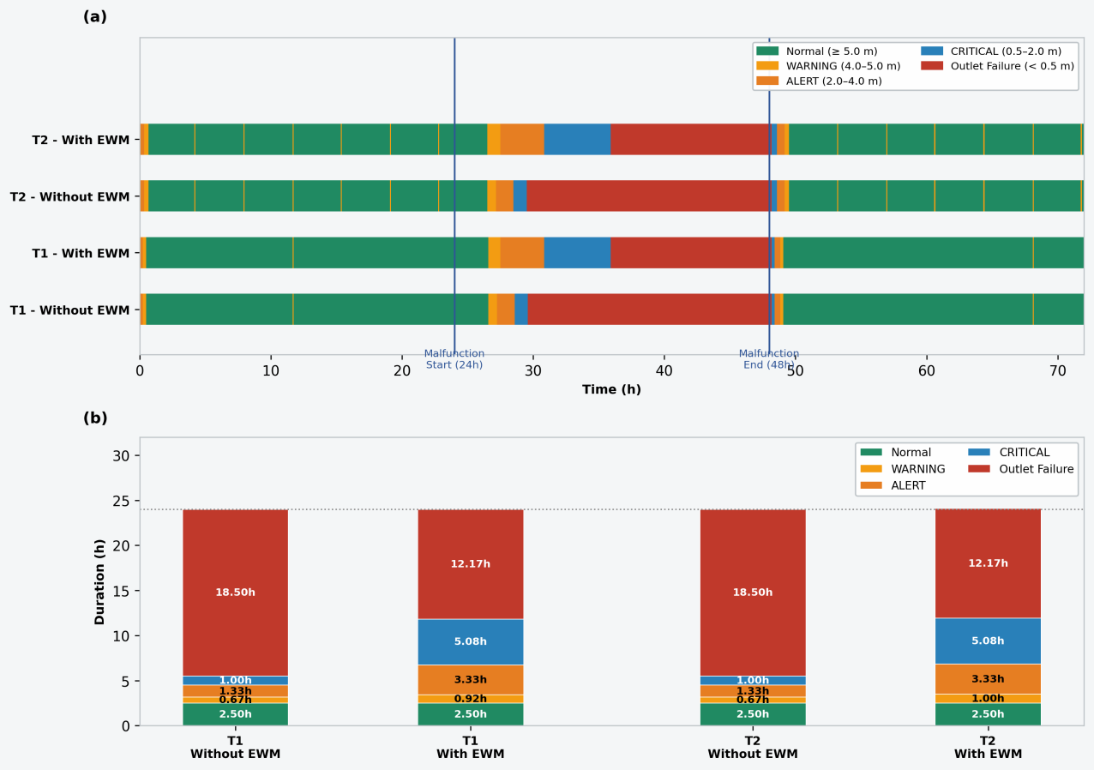
Fig. 4 Temporal evolution and duration distribution of risk states for storage tanks under scenarios without and with EWM. (a) Time-series trajectories of tank water levels and risk-state boundaries; (b) Duration partitioning across distinct risk tiers.
Table 4: Tank state durations and Outlet Failure timings for Tanks T1 and T2
Scenario | Tank ID | Normal (≥ 5.0 m) | Warning (< 5.0 m) | Alert (< 4.0 m) | Critical (< 2.0 m) | Outlet Failure (< 0.50 m) | Total Outflow Duration
Without EWM | T1 | 0.00 h | 0.00 h | 2.50 h | 3.00 h | 18.50 h | 5.50 h
 | T2 | 0.00 h | 0.00 h | 2.42 h | 3.00 h | 18.58 h | 5.42 h
With EWM | T1 | 0.00 h | 1.00 h | 3.50 h | 7.33 h | 12.17 h | 11.83 h
 | T2 | 0.00 h | 1.00 h | 3.50 h | 7.33 h | 12.17 h | 11.83 h

3.2 Pressure Trajectories and Dual-Metric Water Accounting
EWM sustains network pressure above the 0.10 MPa emergency threshold throughout the 24-h outage period. Figure 5 plots network-averaged junction pressure $P_{avg}\left(t\right)$ across the full 72-h simulation horizon. During pre-fault conditions $\left(0≤t<24 h\right)$, $P_{avg}$ stabilises at 55.23 m (0.541 MPa). After pump shutdown at t = 24 h, the baseline pressure curve declines rapidly. At t = 30.2 h, tank depletion and outlet closure drive network pressure to 0.00 MPa, resulting in a complete zero-supply blackout lasting the subsequent 17.8 h. When EWM is enabled, demand is progressively reduced to 70%, 40%, and finally 20% of baseline. Hydraulic head loss diminishes and tank depletion slows, such that the EWM pressure trajectory remains above the 0.10 MPa emergency service threshold over $24≤t≤48 h$. The shaded region between the two curves corresponds to an increase in ${RI}_{pressure}$ from 0.22 to 0.84.
Sole reliance on pressure preservation metrics can overestimate sustained service performance. Figure 6(a) compares the two resilience indices for $24≤t≤48 h$, while Figure 6(b) and Table 5 summarise volumetric water balances against the reference demand volume ${\text{V}}_{\text{reg}}\text{=}\text{7,822.8}$m³. As illustrated in Figure 6(a), ${\text{RI}}_{\text{pressure}}$ rises substantially from 0.22 to 0.84, whereas ${\text{RI}}_{\text{service}}$ increases modestly from 0.23 to 0.29. The discrepancy is explained by volumetric outcomes in Figure 6(b). Without EWM, unrestricted full demand empties tank storage within approximately 6 h, delivering only 1,353.5 m³ before prolonged supply interruption. With EWM, continuous low-rate discharge yields a delivered volume of 1,843.1 m³, representing a net volumetric gain of 489.6 m³ (36.2%). Cumulative unmet demand falls from 6,469.3 m³ to 5,979.7 m³. Tank-level early warning signals enable stepwise outflow curtailment, slowing storage drawdown, delaying outlet closure, and extending the window of partial water delivery.
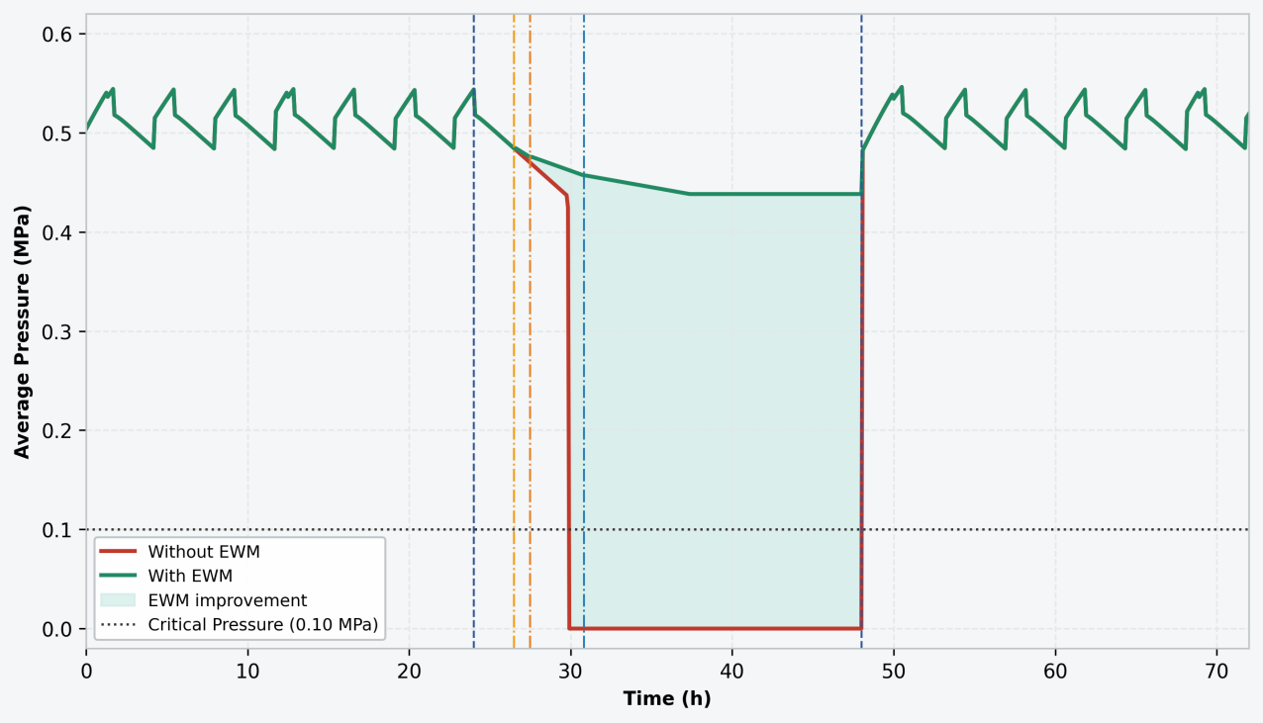
Fig. 5 Network-wide average junction pressure ${\text{P}}_{\text{avg}}\left(\text{t}\right)$ and temporal performance trajectories across the 72-h simulation horizon for scenarios without and with EWM.
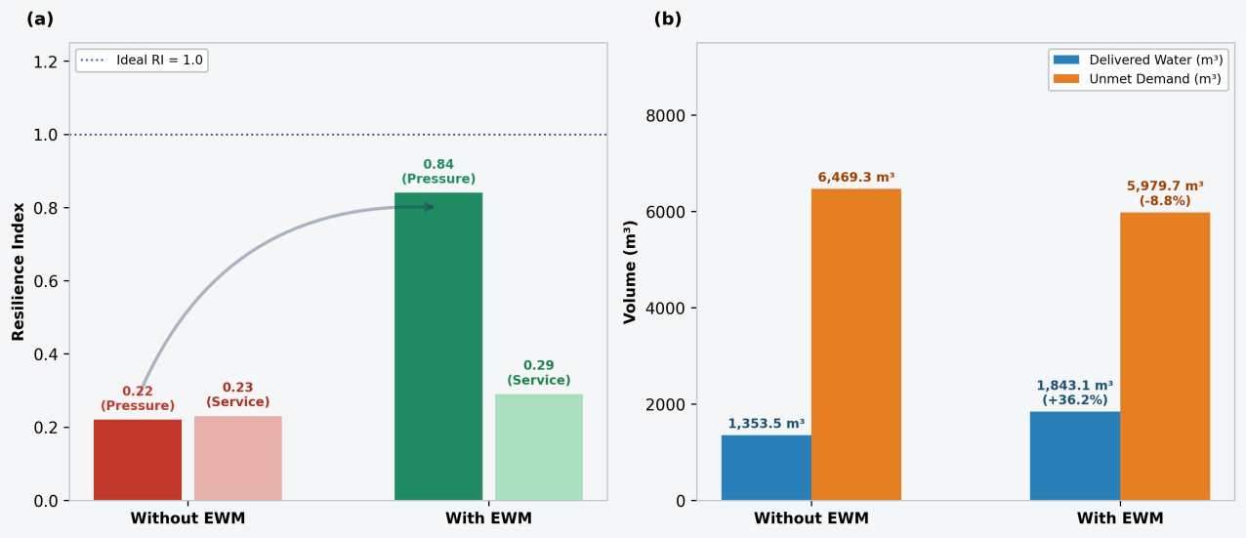
Fig. 6. Dual-metric resilience comparison and volumetric water accounting over t = 24–48 h. (a) compares Pressure Resilience Index $\left({\text{RI}}_{\text{pressure}}\right)$ and Service Resilience Index $\left({\text{RI}}_{\text{service}}\right)$; (b) illustrates cumulative delivered water volume $\left({\text{V}}_{\text{del}}\right)$ and unmet demand $\left({\text{V}}_{\text{unmet}}\right)$.
Table 5: Dual-metric resilience assessment and volumetric water accounting (t = 24–48 h)
Metric Category | Performance Indicator | Baseline (Without EWM) | Proposed (With EWM) | Net Change (Δ) | Operational Interpretation
Resilience Index | ${\text{RI}}_{\text{pressure}}$ | 0.22 | 0.84 | +0.62 | Maintenance of hydraulic head above critical service thresholds
 | ${\text{RI}}_{\text{service}}$ | 0.23 | 0.29 | +0.058 | Continuity of actual delivered water service
Water Accounting | $${\text{V}}_{\text{del}}$$ | 1,353.5 m³ | 1,843.1 m³ | +489.6 m³ | Net increase in water supplied to end users
 | $${\text{V}}_{\text{unmet}}$$ | 6,469.3 m³ | 5,979.7 m³ | -8.8% | Relative reduction in volumetric supply deficit
 | $${\text{V}}_{req}$$ | 7,822.8 m³ | 7,822.8 m³ | 0.0 m³ | Uncurtailed baseline demand volume (shared reference)

3.3 Multi-Factor Sensitivity and Operational Boundaries
The performance benefits of EWM exhibit stress-dependent behaviour: improvements are most pronounced under prolonged outages and limited tank storage, while demand curtailment can yield negative service outcomes under low-stress disturbance conditions. Figure 7(a) quantifies delivered-volume gains across outage durations ranging from 12 h to 48 h, identifying an operational threshold near 18 h. For a 12-h outage, passive tank storage is sufficient to sustain supply without outlet closure. Active demand curtailment excessively restricts water delivery: delivered volume declines by 4.7%, unmet demand rises by 1.4%, and ${\text{RI}}_{\text{service}}$ falls from 0.46 to 0.43, despite an increase in ${\text{RI}}_{\text{pressure}}$ from 0.43 to 0.89. For outages longer than 18 h, uncontrolled demand depletes tank storage, and EWM generates positive performance gains, lifting delivered volume by 36.2% at 24 h and 117.9% at 48 h. Corresponding dual-index results for each fault duration are listed in Table 6..
Figure 7(b) shows that volumetric benefits diminish as tank diameter increases from 0.6 to 1.4 times the baseline geometry. Gains reach 208.2% under storage-constrained conditions and decline to merely 0.09% where passive physical storage inherently buffers disruptions. Figure 8 presents responses of ${\text{RI}}_{\text{pressure}}$ and ${\text{RI}}_{\text{service}}$ to risk-threshold shifts of ΔH = −1.0 m to +1.0 m. Higher threshold values trigger earlier, more conservative intervention. As ΔH increases, ${\text{RI}}_{\text{pressure}}$ rises from 0.81 to 0.87 and ${\text{RI}}_{\text{service}}$ increases from 0.27 to 0.30, with positive delivered-volume gains ranging from 27.1% to 45.3% (Table 6). Combined with Figure 7(a), these observations delineate feasible operational regimes. EWM delivers greatest value during extended source interruptions in networks with limited storage capacity. For short, low-severity outages, delayed or milder trigger settings are preferable, as premature stringent curtailment can preserve pressure metrics while reducing the volume of water delivered to consumers.
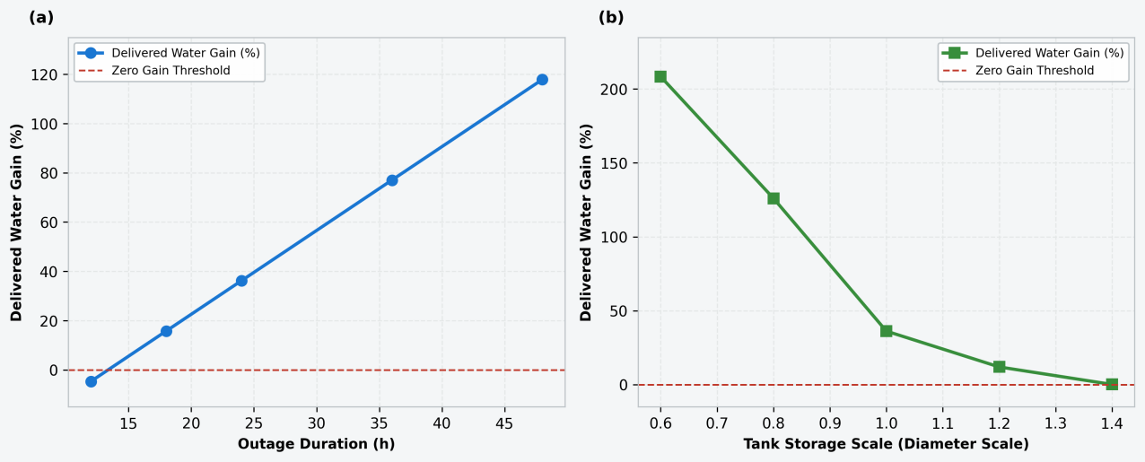
Fig. 7. Sensitivity of delivered water volume gain and unmet demand reduction against (a) source outage duration and (b) tank storage capacity.
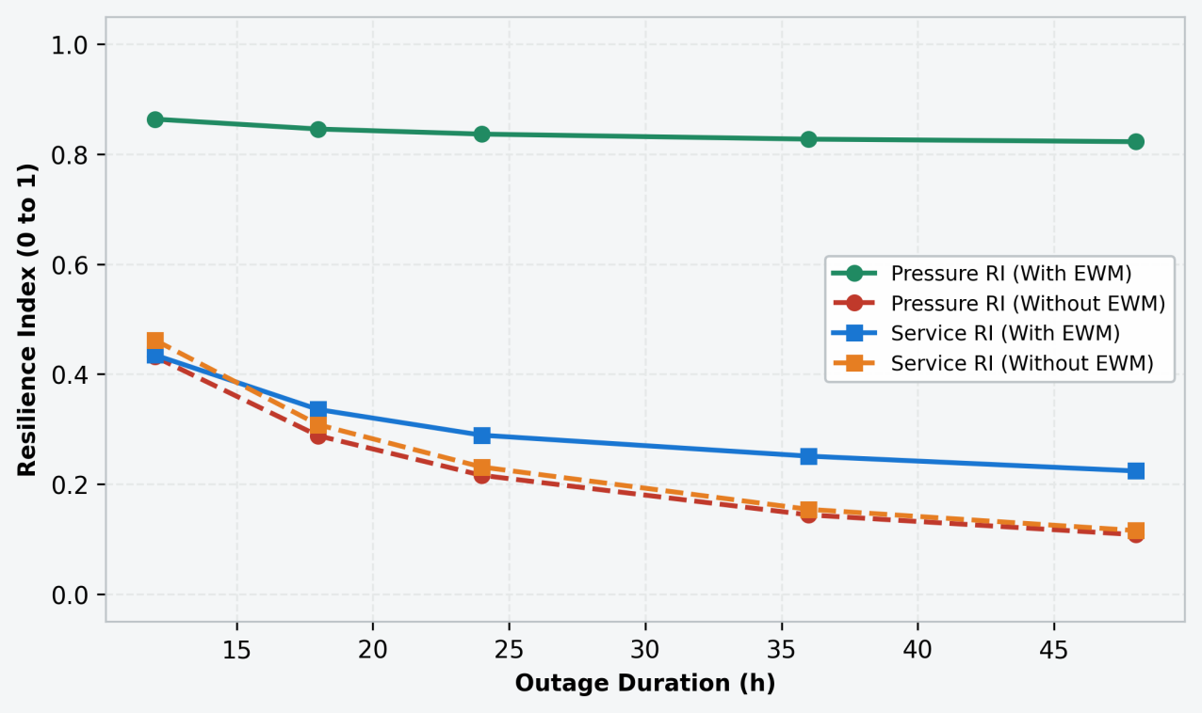
Fig. 8. Sensitivity of Pressure Resilience Index $\left({\text{RI}}_{\text{pressure}}\right)$ and Service Resilience Index $\left({\text{RI}}_{\text{service}}\right)$ across risk threshold shifts (ΔH ∈ [-1.0, +1.0] m), demonstrating model robustness against threshold calibration uncertainty.
Table 6: Multi-factor sensitivity analysis and operational application boundaries
Sensitivity Factor | Factor Level | ${\text{RI}}_{\text{pressure}}$ (Without / With) | ${\text{RI}}_{\text{service}}$ (Without / With) | Delivered Volume Gain (%) | Unmet Demand Reduction (%) | Operational Regime Characterisation
Threshold Shift (Δ H) | -1.0 m | 0.22 / 0.81 | 0.23 / 0.27 | +27.1% | -5.8% | Robust Positive Gain: High tolerance to threshold calibration.
 | 0.0 m (Baseline) | 0.22 / 0.84 | 0.23 / 0.29 | +36.2% | -8.8% | Optimal Baseline: Balanced pressure and service gains.
 | +1.0 m | 0.22 / 0.87 | 0.23 / 0.30 | +45.3% | -9.9% | Conservative Trigger: Earlier curtailment preserves more storage.
Tank Diameter (D_{tank}) | 0.6× | 0.09 / 0.77 | 0.09 / 0.22 | +208.2% | -18.7% | Critical EWM Value: Essential for storage-constrained networks.
 | 1.0× (Baseline) | 0.22 / 0.84 | 0.23 / 0.29 | +36.2% | -8.8% | Moderate EWM Value: Substantial service continuity gain.
 | 1.4× | 0.51 / 0.90 | 0.51 / 0.53 | +0.09% | -0.08% | Low EWM Value: Passive physical storage dominates.
Fault Duration (T_{fault}) | 12 h | 0.43 / 0.89 | 0.46 / 0.43 | -4.7% | +1.4% | Over-Curtailment Boundary: Unnecessary for minor outages.
 | 24 h (Baseline) | 0.22 / 0.84 | 0.23 / 0.29 | +36.2% | -8.8% | High EWM Value: Prevents complete zero-supply collapse.
 | 48 h | 0.11 / 0.79 | 0.11 / 0.22 | +117.9% | -13.6% | Vital EWM Value: Maintains lifeline water supply during prolonged events.

4. Discussion
4.1 Three-Layer Cyber-Physical Linkage and Time-Difference Buffer
The resilience gains observed in this work stem not merely from inherent tank storage capacity, but from system-level effects enabled by closed-loop cyber–physical coordination. As illustrated in Figure 3, the sensing layer captures tank-level drawdown immediately after source outage initiation at t = 24 h. The control layer subsequently translates hydraulic signals into staged demand retention ratios $\left(\text{γ} \text{∈} \left\{\text{1.00, 0.70, 0.40, 0.20}\right\}\right)$, and the hydraulic layer executes demand curtailment to moderate outflow. This sequential control logic slows tank depletion and delays outlet failure, consistent with the redistributed risk-state durations presented in Figure 4 and Table 4. Accordingly, the proposed framework transforms static passive storage margins into a usable operational response window defined as the time-difference buffer.
This mechanism aligns with existing CPS research highlighting temporal mismatches between cyber monitoring workflows and the progressive degradation of physical infrastructure (Arghandeh et al., 2016; Hassanzadeh et al., 2020). In this study, high-frequency data acquisition facilitates timely control interventions before irreversible hydraulic collapse, sustaining network pressure above the 0.10 MPa emergency threshold throughout the simulated outage (Figure 5). A core implication emerges: system resilience constitutes an emergent property of integrated sensing–control–hydraulic coupling, rather than an intrinsic attribute of isolated physical assets such as storage tanks.
4.2 Interpreting the Divergence Between Pressure and Service Resilience
A key empirical finding is the decoupling of pressure resilience and service resilience under emergency demand curtailment. Over the outage horizon, ${\text{RI}}_{\text{pressure}}$ rises substantially from 0.22 to 0.84, while ${\text{RI}}_{\text{service}}$ increases modestly from 0.23 to 0.29 (Fig 6(a), Table 5). Such divergence is an inherent feature of pressure-oriented network operation: pressure levels can be preserved via demand suppression, yet sustained minimum pressure does not guarantee consistent volumetric water delivery to end users. Consequently, resilience frameworks relying solely on pressure metrics risk overestimating consumer-level service continuity when active demand management is deployed.
This observation advances previous resilience assessment studies that predominantly adopt hydraulic or topological indicators (Casal-Campos et al., 2015; Meng et al., 2018). By integrating ${\text{RI}}_{\text{pressure}}$, ${\text{RI}}_{\text{service}}$ and volumetric water accounting, this study establishes an evaluation framework more closely aligned with operational decision-making. Volumetric outputs in Figure 6(b) clarify the underlying trade-off: EWM delivers a 36.2% increase in supplied volume and an 8.8% reduction in unmet demand. Instead of restoring nominal service conditions, the strategy reorganises supply patterns, replacing brief full-rate delivery followed by complete blackouts with extended low-rate supply. For emergency management, this trade-off carries practical value and requires explicit quantification in contingency planning.
4.3 Operational Boundaries and Practical Constraints
Sensitivity simulations confirm that the performance benefits of EWM are stress-dependent rather than universally applicable. The 12 h outage scenario in Figure 7(a) identifies an over-curtailment regime: although pressure conditions improve, service outcomes deteriorate, accompanied by reduced ${\text{RI}}_{\text{service}}$and lower cumulative delivered volume. By contrast, outages lasting longer than approximately 18 h yield consistent positive gains, which amplify further with extended disruption duration. Figure 7(b) additionally reveals strong reliance on available storage capacity: EWM delivers prominent benefits for storage-constrained distribution networks, whereas marginal performance improvements diminish when passive buffering from large tanks is sufficient. These trends demonstrate that the conservatism of control trigger thresholds should be calibrated according to disturbance severity and network storage endowment.

Multiple practical constraints must be addressed prior to field implementation. First, prolonged low-flow regimes tend to extend water age and accelerate disinfectant decay, introducing potential water quality risks (Sitzenfrei, 2021; WHO, 2022; Zou et al., 2023). Second, even when network-averaged pressure satisfies emergency criteria, localised transient head drops may create backflow intrusion hazards (Mignot & Dewals, 2022; Taiwo et al., 2023). Third, uniform nodal curtailment is adopted within the present modelling setup; real-world deployment requires differentiated allocation to prioritise critical facilities and lifeline consumers (Sadien et al., 2024; Zhang et al., 2025). These limitations do not invalidate the hydraulic findings reported herein, but delineate boundary conditions for responsible real-world translation of the EWM strategy.
4.4 Future Direction: Adaptive Control with Digital-Twin Integration
A promising research pathway involves substituting static fixed thresholds with adaptive trigger logic embedded within digital twin architectures. The current WNTR–EPANET 2.2 modelling platform can be extended to an online shadow model capable of ingesting real-time SCADA measurements and forecasting short-term tank drawdown risks. Within this framework, risk threshold ΔH and demand retention coefficient $γ$ can be dynamically updated according to real-time storage status, outage evolution and demand predictions. This development directly mitigates the over-curtailment risk observed under low-stress disturbances (Figure 7(a)), while retaining resilience benefits for prolonged, severe disruptions.
From a methodological perspective, lightweight data-driven agents (e.g., reinforcement learning or gradient-boosted decision trees) trained on ensembles of multi-scenario simulations can support robust control policy selection without continuous full-scale online retraining. Optimisation targets should adopt a multi-criteria formulation: maintaining emergency pressure thresholds, maximising cumulative delivered volume, and mitigating inequitable service deprivation across consumer groups. Following this trajectory, early-warning mechanisms evolve from static threshold-based alarm systems towards adaptive resilience governance, enhancing both operational efficiency and social acceptability during water supply emergencies.
5. Conclusions
This study proposes and validates a proactive closed-loop resilience enhancement framework for urban water supply cyber–physical systems (CPS) facing extreme full source interruption. Built upon a WNTR–EPANET 2.2 co-simulation platform integrated with SCADA-based monitoring and automated control logic, the research demonstrates that water system resilience is not merely determined by static physical infrastructures such as tank storage and pipeline capacity, but emerges as a dynamic system-level capability driven by cyber-physical synergy. By leveraging the inherent temporal mismatch between high-speed cyber sensing and gradual physical hydraulic degradation, the developed early warning management (EWM) strategy transforms passive storage margins into quantifiable operational time buffers. This core mechanism effectively delays tank outlet failure and sustains network hydraulic head above emergency thresholds throughout extreme disruption events, fundamentally shifting system failure behaviour from abrupt catastrophic collapse to controllable gradual degradation.
Quantitative simulation results verify the significant performance improvements brought by graded demand management intervention. Under the benchmark 24-hour complete source outage scenario, tiered demand retention strategies substantially enhance dual-dimensional resilience performance, with the pressure-based resilience index rising from 0.22 to 0.84 and the service-based resilience index increasing from 0.23 to 0.29. Correspondingly, the framework achieves a 36.2% increment in cumulative delivered water volume and an 8.8% reduction in unmet water demand, effectively improving emergency water supply sustainability. Further multi-factor sensitivity analysis clarifies the stress-dependent effectiveness and explicit operational boundaries of EWM. The proactive intervention strategy delivers prominent resilience gains for prolonged outages and storage-constrained water distribution systems. Nevertheless, aggressive early triggering under short-duration, low-stress disruptions may trigger excessive demand curtailment, leading to deteriorated consumer water service and negative operational outcomes.
The research findings yield actionable managerial and operational implications for municipal water emergency scheduling and smart grid governance. To improve the proactive resilience of water supply CPS, utility departments can embed threshold-based graded demand control logic into existing SCADA/PLC architectures to realise automated closed-loop emergency response. In practical emergency planning, differentiated demand curtailment schemes should be adopted to prioritise water supply for critical facilities and lifeline users while reducing non-essential loads. Moreover, risk warning thresholds need targeted calibration according to network-specific storage characteristics and hydraulic response features, ensuring timely and moderate intervention before the system reaches physical failure limits.
This study also identifies viable directions for future optimisation and engineering translation. Subsequent research can upgrade the static threshold control framework to adaptive digital twin-driven intelligent control, enabling dynamic adjustment of warning criteria and demand retention coefficients under variable disturbance conditions. Furthermore, integrating water quality evolution mechanisms and socially equitable differentiated curtailment strategies will further improve the practicality and robustness of the framework, facilitating its large-scale field deployment in smart water supply emergency management.

References
Alexandra, C, Daniell, K A, Guillaume, J, Saraswat, C, Feldman, H R (2023). Cyber-physical systems in water management and governance. Current Opinion in Environmental Sustainability, 62, 101290.
Ande, R, Adebisi, B, Hammoudeh, M, Saleem, J (2020). Internet of Things: Evolution and technologies from a security perspective. Sustainable Cities and Society, 54, 101728.
Arghandeh, R, Von Meier, A, Mehrmanesh, L, Mili, L (2016). On the definition of cyber-physical resilience in power systems. Renewable and Sustainable Energy Reviews, 58, 1060-1069.
Argyroudis, S A, Mitoulis, S A, Chatzi, E, Baker, J W, Brilakis, I, Gkoumas, K, Linkov, I (2022). Digital technologies can enhance climate resilience of critical infrastructure. Climate Risk Management, 35, 100387.
Bhardwaj, A, Gupta, A, Khatri, S K (2021). Cyber-physical system security in smart water networks: A review. IEEE Transactions on Industrial Informatics, 17(10): 7125-7136.
Boltz, F, Poff, N L, Folke, C, Kete, N, Brown, C M, Freeman, S S G, Rockstrom, J (2019). Water is a master variable: Solving for resilience in the modern era. Water Security, 8, 100048.
Cai, B, Zhang, Y, Wang, H, Liu, Y, Ji, R, Gao, C, Liu, J (2021). Resilience evaluation methodology of engineering systems with dynamic-Bayesian-network-based degradation and maintenance. Reliability Engineering & System Safety, 209, 107464.
Casal-Campos, A, Sadr, S M, Fu, G, Butler, D (2018). Reliable, resilient and sustainable urban drainage systems: An analysis of robustness under deep uncertainty. Environmental Science & Technology, 52(16): 9008-9021.
Chen, B, Li, H, Sun, G (2025). Seismic resilience assessment method and multi-objective optimal recovery strategy for large-scale urban water distribution network system. International Journal of Disaster Risk Reduction, 127, 105689.
Chen, Z, Zhang, S, Dui, H (2025). Importance-based risk evaluation methodology in transportation cyber-physical systems. Frontiers of Engineering Management, 12(2): 291-304.
Creaco, E, Franchini, M, Walski, T (2016). Accounting for pressure-driven demand in water distribution network optimization. Journal of Water Resources Planning and Management, 142(9): 04016030.
Cui, Z, Guo, W, Zhang, T (2022). Superposition control of extreme water levels in surge tanks of pumped storage power station with two turbines under combined operating conditions. Journal of Energy Storage, 56, 105894.
Garcia-Perez, A, Cegarra-Navarro, J G, Sallos, M P, Martinez-Caro, E, Chinnaswamy, A (2023). Resilience in healthcare systems: Cyber security and digital transformation. Technovation, 121, 102583.
Hassanzadeh, A, Rasekh, A, Galelli, S, Aez, M, Taormina, R, Ostfeld, A, Banks, M K (2020). A review of cybersecurity incidents in the water sector. Journal of Environmental Engineering, 146(5): 03120003.
He, S, Zhou, Y, Yang, Y, Liu, T, Zhou, Y, Li, J, Guan, X (2024). Cascading failure in cyber-physical systems: A review on failure modeling and vulnerability analysis. IEEE Transactions on Cybernetics, 54(12): 7936-7954.
He, Z, Huang, H, Choi, H, Bilgihan, A (2023). Building organizational resilience with digital transformation. Journal of Service Management, 34(1): 147-171.
Holling, C S (1973). Resilience and stability of ecological systems. Annual Review of Ecology and Systematics, 4(1): 1-23.
Hosseini, S, Barker, K, Ramirez-Marquez, J E (2016). A review of definitions and measures of system resilience. Reliability Engineering & System Safety, 145, 47-61.
Hou, B, Huang, J, Miao, H, Zhao, X, Wu, S (2023). Seismic resilience evaluation of water distribution systems considering hydraulic and water quality performance. International Journal of Disaster Risk Reduction, 93, 103756.
Jiang, L, Hu, Y, Li, H, Shao, X, Zhang, X, Kan, Q, Kang, G (2025). A cGAN-based fatigue life prediction of 316 austenitic stainless steel in high-temperature and high-pressure water environments. International Journal of Fatigue, 190, 108633.
Juan-Garcia, P, Butler, D, Comas, J, Darch, G, Sweetapple, C, Thornton, A, Corominas, L (2017). Resilience theory incorporated into urban wastewater systems management: State of the art. Water Research, 115, 149-161.
Khan, R, Zakarya, M, Balasubramanian, V, Jan, M A, Menon, V G (2020). Smart sensing-enabled decision support system for water scheduling in orange orchard. IEEE Sensors Journal, 21(16): 17492-17499.
Khattak, Z H (2024). Cybersecurity vulnerability and resilience of cooperative driving automation for energy efficiency and flow stability in smart cities. Sustainable Cities and Society, 106, 105368.
Liao, C, Chen, X, Gao, Z (2025). Toward smart charging, synergistic infrastructure and storable grid for coordinated power and transportation systems. Frontiers of Engineering Management, 12(3): 704-709.
Liserra, T, Maglionico, M, Ciriello, V, Di Federico, V (2014). Evaluation of reliability indicators for WDNs with demand-driven and pressure-driven models. Water Resources Management, 28(5): 1201-1217.
Liu, D (2019). Evaluating the dynamic resilience process of a regional water resource system through the nexus approach and resilience routing analysis. Journal of Hydrology, 578, 124028.
Liu, L, Mijic, A (2025). Performance-based resilience assessment in integrated water systems: Challenges and opportunities. Journal of Hydrology, 630, 134042.
Liu, L, Zhou, X, Duenas-Osorio, L, Stadler, L, Li, Q (2023). Hybrid wastewater treatment and reuse enhances urban water system resilience to disruptive incidents. Nature Water, 1(12): 1048-1058.
Liu, W, Song, Z, Ouyang, M, Li, J (2020). Recovery-based seismic resilience enhancement strategies of water distribution networks. Reliability Engineering & System Safety, 203, 107088.
Liu, Z, Xu, W, Wang, Y (2023). Resilience assessment and enhancement of urban water supply systems under critical component failures. Frontiers of Engineering Management, 10(2): 245-258.
Madiziyire, S, Stagner, J, Carriveau, R, Biswas, N, Johnson, K, Fisk, A (2025). Evaluation of response measures for water cutoffs using pressure driven analysis simulations. Water Research, 268, 124737.
Meng, F, Fu, G, Farmani, R, Sweetapple, C, Butler, D (2018). Topological ranking of water distribution networks for resilience assessment. Water Research, 129, 316-328.
Mignot, E, Dewals, B (2022). Hydraulic modelling of inland urban flooding: Recent advances. Journal of Hydrology, 609, 127763.
Ministry of Housing and Urban-Rural Development of China (MOHURD) (2018). Standard for Outdoor Water Supply Engineering (GB 50013-2018). China Architecture & Building Press, Beijing, China.
Mohebbi, S, Zhang, Q, Wells, E C, Zhao, T, Nguyen, H, Li, M, Ou, X (2020). Cyber-physical-social interdependencies and organizational resilience: A review of water, transportation, and cyber infrastructure systems and processes. Sustainable Cities and Society, 62, 102327.
Moreno-Sader, K, Jain, P, Tenorio, L C B, Mannan, M S, El-Halwagi, M M (2019). Integrated approach of safety, sustainability, reliability, and resilience analysis via a return on investment metric. ACS Sustainable Chemistry & Engineering, 7(24): 19522-19536.
Ostfeld, A, Salomons, E (2004). Optimal layout of water distribution networks security sensors. Journal of Water Resources Planning and Management, 130(5): 377-385.
Roach, T, Kapelan, Z (2017). Infrastructure resilience assessment using pressure-dependent hydraulic modeling of water distribution networks. Water Resources Management, 31(11): 3505-3519.
Roach, T, Kapelan, Z, Ledbetter, R (2018). Resilience-based performance metrics for water resources management under uncertainty. Advances in Water Resources, 116, 18-28.
Sadien, M, Doorga, J R, Rughooputh, S D (2024). Assessment of tangible coastal inundation damage related to critical infrastructure and buildings: The case of Mauritius Island. International Journal of Disaster Risk Reduction, 114, 104909.
Savic, D A, Banyard, J K (Eds) (2024). Water Supply and Distribution Systems. Emerald Group Publishing, Leeds, UK.
Sitzenfrei, R (2021). Using complex network analysis for water quality assessment in large water distribution systems. Water Research, 201, 117359.
Sun, H, Yang, M, Wang, H (2022). Resilience-based approach to maintenance asset and operational cost planning. Process Safety and Environmental Protection, 162, 987-997.
Taiwo, R, Ben Seghier, M E A, Zayed, T (2023). Toward sustainable water infrastructure: The state-of-the-art for modeling the failure probability of water pipes. Water Resources Research, 59(4), e2022WR033256.
Taormina, R, Galelli, S, Tippenhauer, N O, Salomons, E, Ostfeld, A, Eliades, D G, Ohar, Z (2018). Battle of the attack detection algorithms: Disclosing cyber attacks on water distribution networks. Journal of Water Resources Planning and Management, 144(8): 04018048.
Walski, T M, Brill, E D, Gessler, J, Goulter, I C, Jeppson, R M, Lansey, K, Ormsbee, L (1987). Battle of the network models: Epilogue. Journal of Water Resources Planning and Management, 113(2): 191-203.
Walski, T M, Chase, D V, Savic, D A, Grayman, W, Beckwith, S, Koelle, E (2003). Advanced Water Distribution Modeling and Management. Haestad Methods, Waterbury, CT, USA.
Wang, B, Shen, C (2023). A time-varying observer-based approach to equilibrium estimation and compensation for synchronization of heterogeneous nonlinear cyber-physical systems. IEEE Transactions on Automatic Control, 68(10): 6176-6183.
Wardropper, C, Brookfield, A (2022). Decision-support systems for water management. Journal of Hydrology, 610, 127928.
World Health Organization (WHO) (2022). Guidelines for Drinking-Water Quality: Fourth Edition Incorporating the First and Second Addenda. World Health Organization, Geneva, Switzerland.
Wu, G, Li, Z S (2021). Cyber-Physical Power System (CPPS): A review on measures and optimization methods of system resilience. Frontiers of Engineering Management, 8(4): 503-518.
Xu, W, Zhou, X, Xin, K, Boxall, J, Yan, H, Tao, T (2020). Disturbance extraction for burst detection in water distribution networks using pressure measurements. Water Resources Research, 56(5), e2019WR025526.
Yadav, G, Paul, K (2021). Architecture and security of SCADA systems: A review. International Journal of Critical Infrastructure Protection, 34, 100433.
Zhang, C, Chen, R, Wang, S, Dui, H, Zhang, Y (2022). Resilience efficiency importance measure for the selection of a component maintenance strategy to improve system performance recovery. Reliability Engineering & System Safety, 217, 108070.
Zhang, J, Qiu, W, Wang, Q, Yao, T, Hu, C, Liu, Y (2024). Extreme water level of surge chamber in hydropower plant under combined operating conditions. Chaos, Solitons & Fractals, 178, 114362.
Zhang, Y, Yin, H, Liu, M, Kong, F, Xu, J (2025). Evaluating the effectiveness of environmental sustainability indicators in optimizing green-grey infrastructure for sustainable stormwater management. Water Research, 272, 122932.
Zou, X Y, Peng, X Y, Zhao, X X, Chang, C P (2023). The impact of extreme weather events on water quality: International evidence. Natural Hazards, 115(1): 1-21.

